OV-1-6S-GAS Valve change-over
XP33232002 gas valve replaced with XP30405300019 – gas valve

The left side is the new valve thermostat, and the right side is the old one. The interfaces of the two thermostats are different, which will cause the length of the aluminium tube to be different.
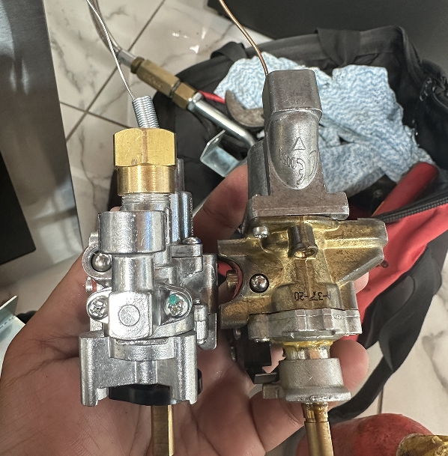

Solution:
1.Replace the screws with M4x20 screws.
2.Adjust the installation angle by tightening the two screws in the blue box to use it.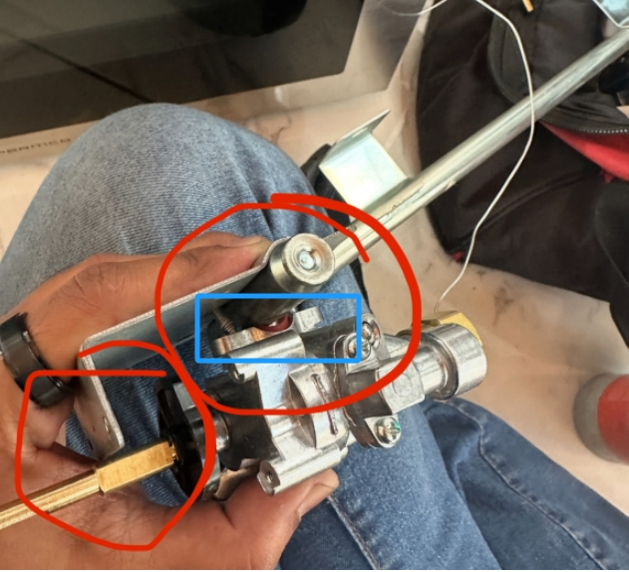

3.If the length of these two aluminium tubes is too long or too short, you can remove the rear cover plate, loosen the screws that fix the cavity, and slightly adjust the length of these two aluminium tubes to fit the thermostat.
